

To whom it may concern,

It is my pleasure to recommend Xiaoqin Feng for her Ph.D. application in your esteemed program. I have been her work advisor for over three years as I have witnessed her growth, particularly in machine learning and natural language processing, as well as her understanding and execution of team communication skills.

While a part of our team, Xiaoqin works in our speech synthesis department as a researcher and engineer developing natural language processing algorithms for text information extraction. Her ability to translate abstract technical proposals into easily executable code demonstrates her comprehension of the functional and technical aspects required to be a successful engineer. For instance, she develops new algorithms and optimizations for tokenization, text normalization, and prosody, which are critical for our text-to-speech system. Moreover, I remember she took more effort into our polyphone prediction, which was her start project, and she completed it perfectly. She published several impacted papers and patents about NLP with her interns and collaborative projects. I regard her as one of the best “worker” and “researcher” in my career life, as she covers patience, responsibility, and intelligence.

During her time with Mobvoi AI Lab, Xiaoqin also excelled as a project master, working with me, the product owner, and fellow technical peers to ensure each project was completed with thorough, weekly retrospective sessions to help guide and direct the team. Xiaoqin surpassed the expectations of her role by setting aside the time to organize the tech sharings for all team members, including the complicated machine learning topics involved in our algorithms and projects. She developed excellent communication and comprehensive skills in these years.

I firmly believe Xiaoqin would be an asset to have in your program. Her innovative mindset and prowess in challenging assumptions make her a strong Ph.D. candidate, especially as they pertain to machine learning and natural language processing. Therefore, I would appreciate your favorable consideration of her application. If you have any further questions, please feel free to contact me. Thank you!

Yours Sincerely,

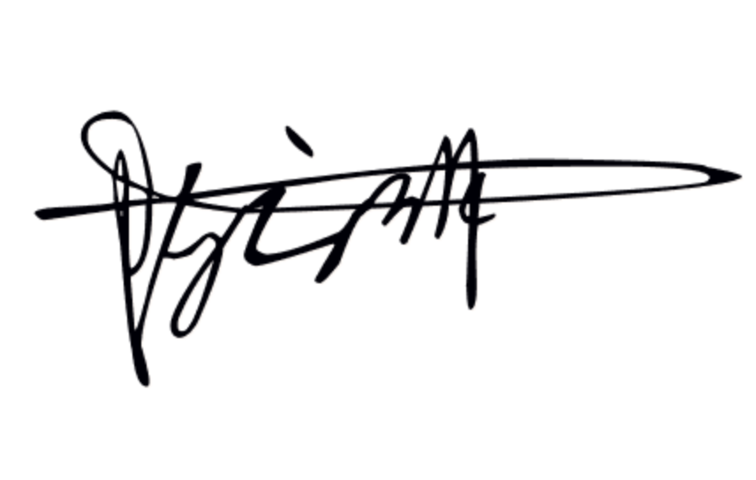

Yunlin Chen  
Technical Director at Mobvoi AI Lab.

yunlinchen@mobvoi.com

November 27, 2022

Mobvoi Corporation | Ronghui, Haidian, Beijing, 100000, China